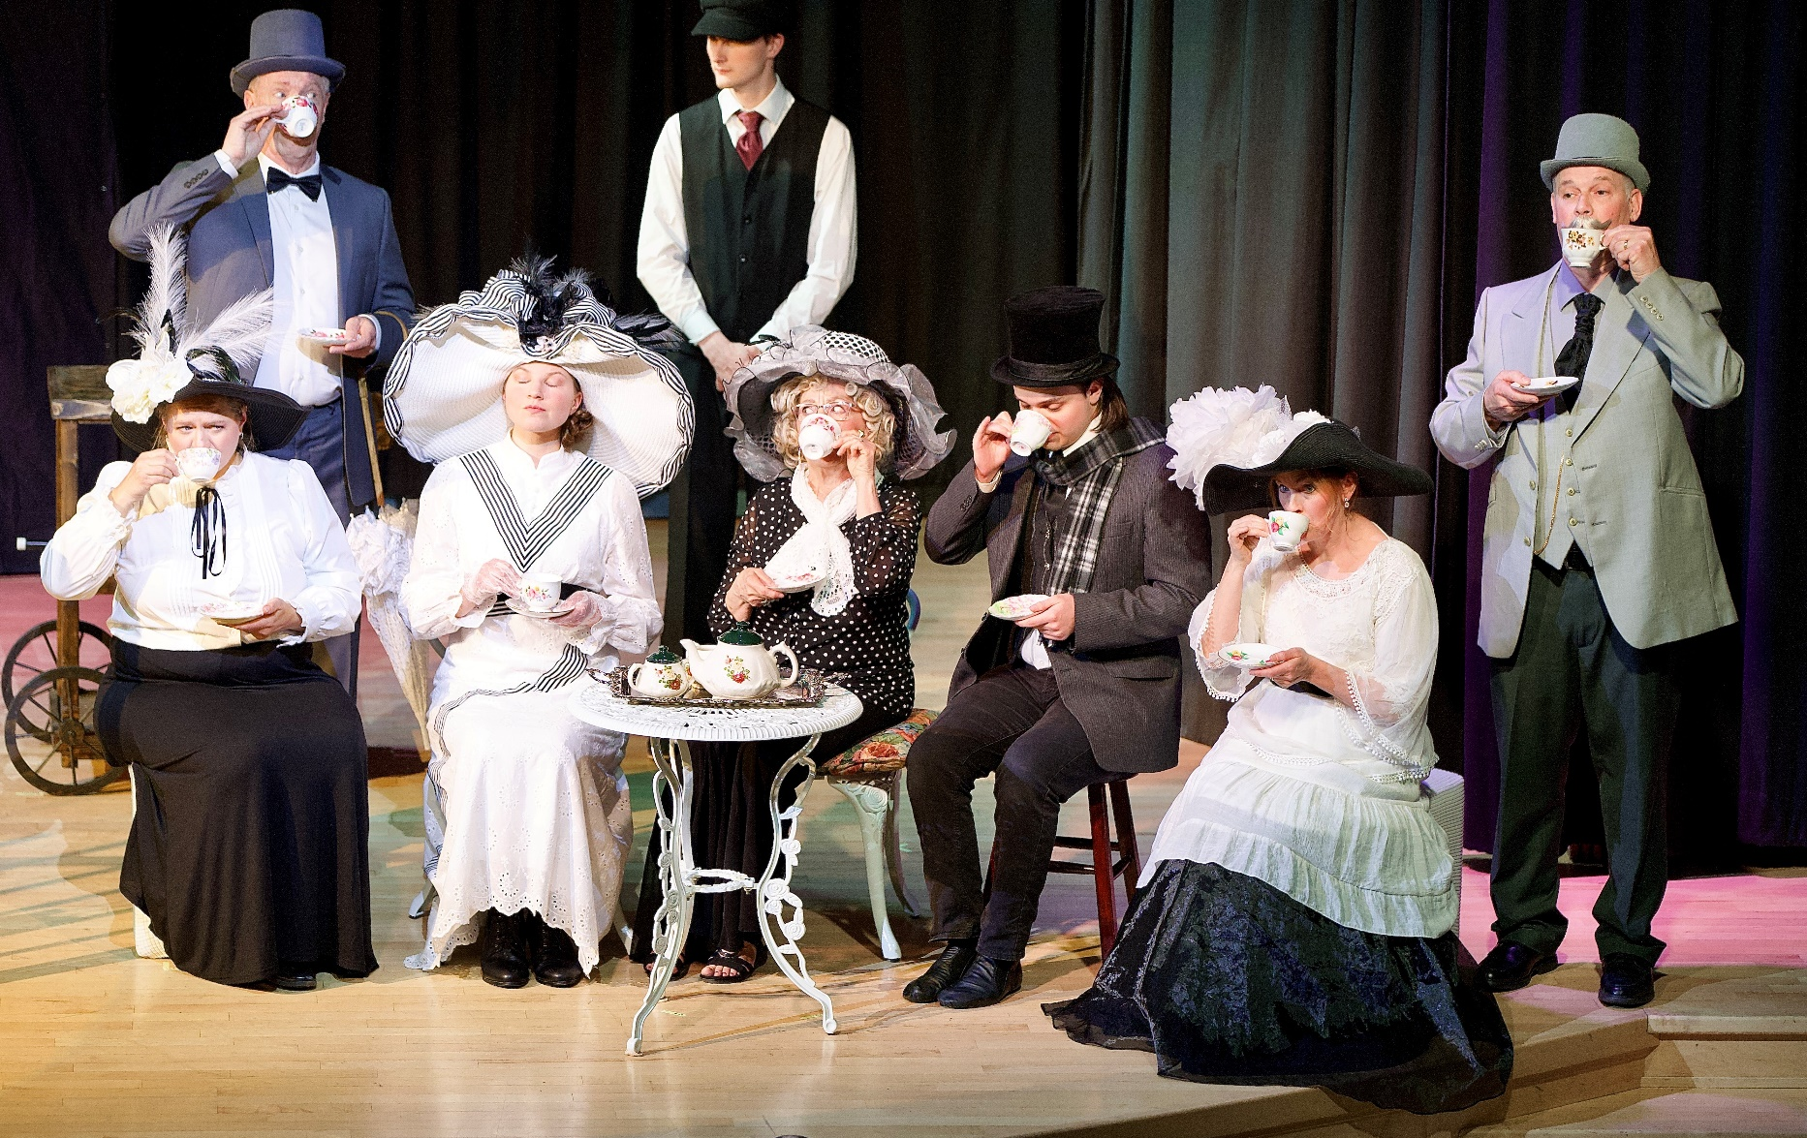
Performance Driven

Eleanor Pickup Arts Centre
Annual Report 2025-26

Performance Driven
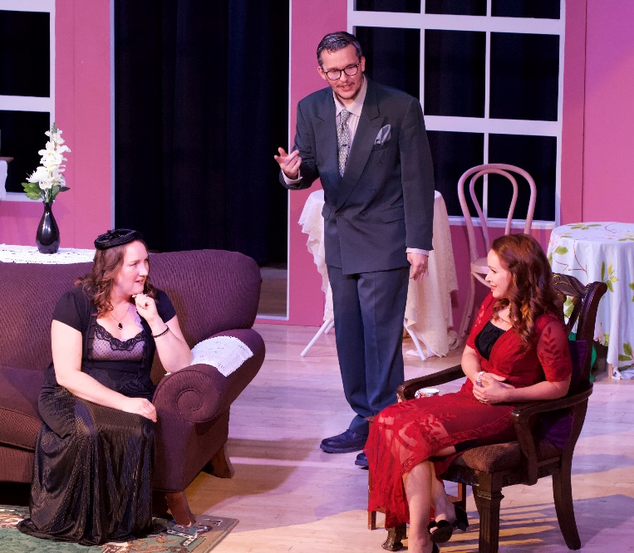
Great performances are always the objective in performing arts! A great performance can illicit spontaneous tears, roaring laughter, profound silence and commonly, thunderous applause. It is the goal of any performer to intensely connect to the audience in a way that makes an experience something to be treasured and remembered for a lifetime. To have such a performance in a facility that is beautiful and inspiring is a joy for both the audience and the artist.
Blithe Spirit

Pictured: Fiddler on the Roof, February 2025
The goal of the Eleanor Pickup Arts Centre society Phase II Expansion is to have a venue that supports great performances. Phase II will include an expanded lobby, additional concession, spacious green room, multi-purpose rehearsal hall, two comfortable dressing rooms, corridor suitable for moving large props, and two income suites. The Expansion will allow for larger theatrical and dance productions, professional preparation areas for performers, rooms for crews to work, secure access and exit from the stage, and comfortable off stage spaces to recharge before acts…truly a performers paradise! The Expansion will also impact programming opportunities that can hosted in the facility in the future, whether it be summer drama camps or community music lessons. It is all about creating opportunities to develop and showcase amazing performances to benefit audiences and artists alike. We are performance driven!

About the Eleanor Pickup Art Centre
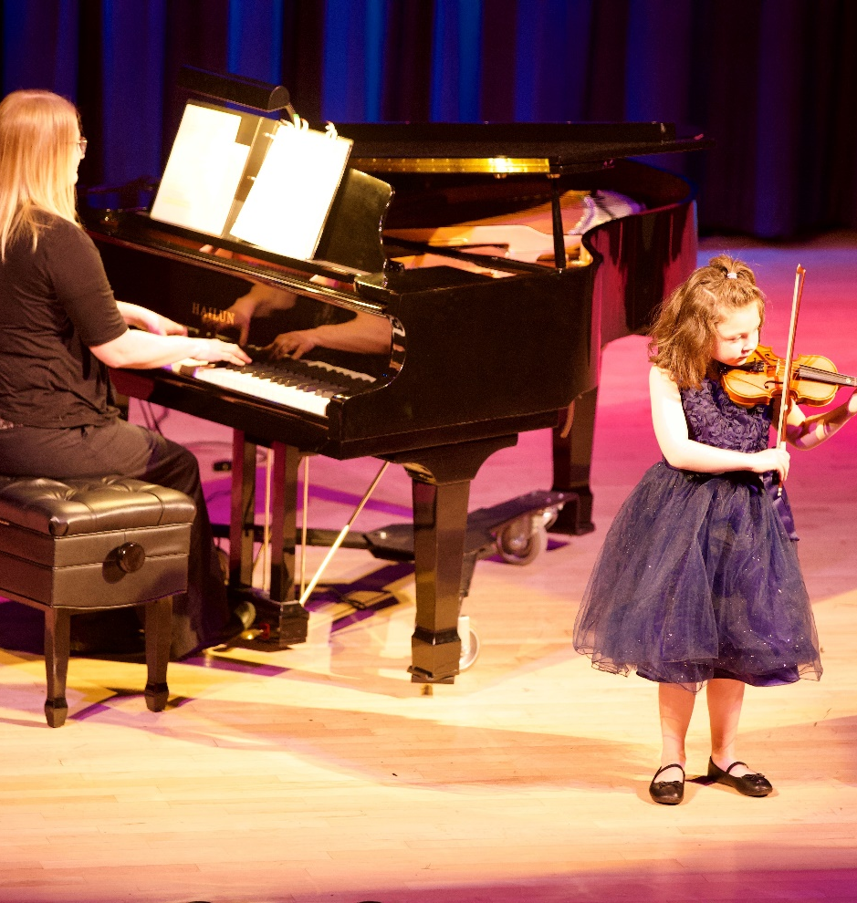
Housed in the historic Cardium Theatre in Drayton Valley, Alberta, the Eleanor Pickup Arts Centre is a vibrant, multipurpose performing arts venue serving Drayton Valley, Brazeau County, and surrounding communities. Dedicated to inspiring participation in the performing arts and contributing to the revitalization of downtown, our non-profit organization provides a welcoming space where youth and adults can create, perform, gather, and experience the power of live entertainment in a treasured local landmark.
Festival Showcase 2026 2026

2025-2026 Eleanor Pickup Art Centre Board of Directors
President-Sandra Bannard
Vice-President-Tammy Pequin
Secretary-Mitzi Kobernik
Treasurer-Karstina Oscar
Theatre Manager-Onawa Hogan
Fundraising Coordinator-Rachel Canton
Volunteer Coordinator-Deanne Medhurst
Marketing & Communications-Svetlana Kos
Construction Committee-Dave Davie
Art Gallery Curator-Donna Wiltse
Construction Committee-Joanne Nelson
Concession Coordinator-Tammy Pequin
Brazeau County Representative-Kara Westerlund
Town of Drayton Valley-Cody Brooks


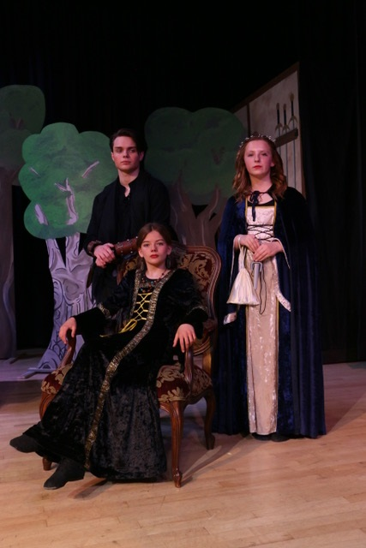
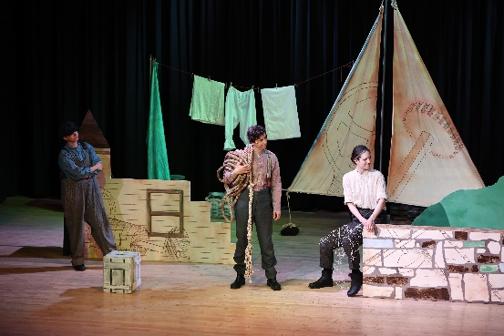
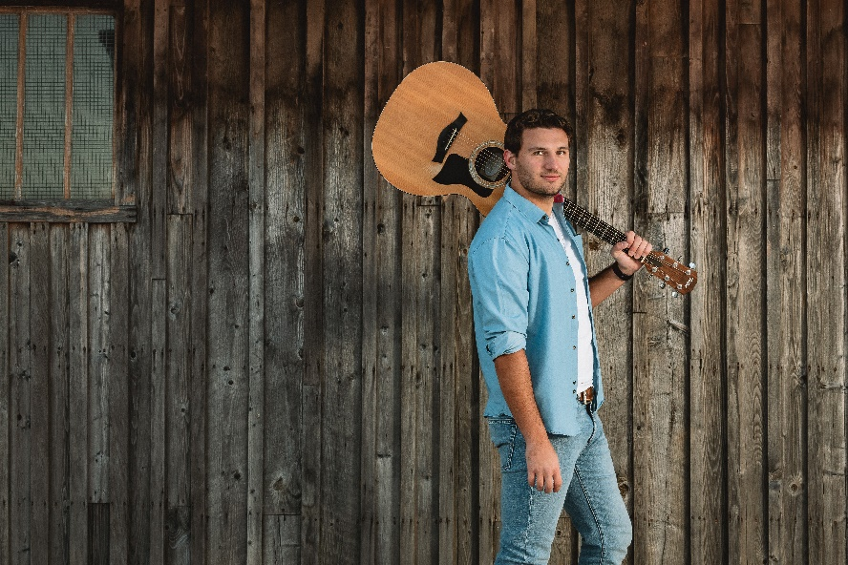
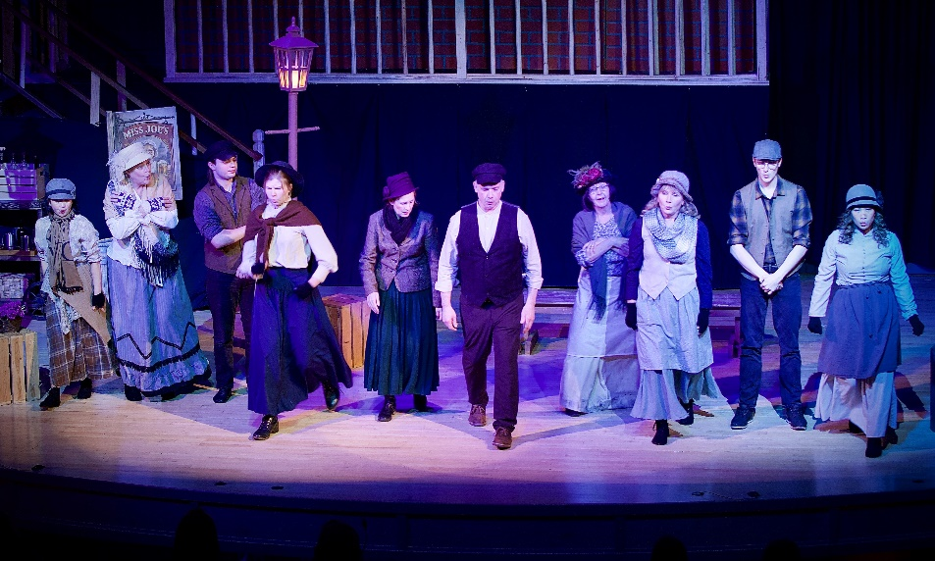
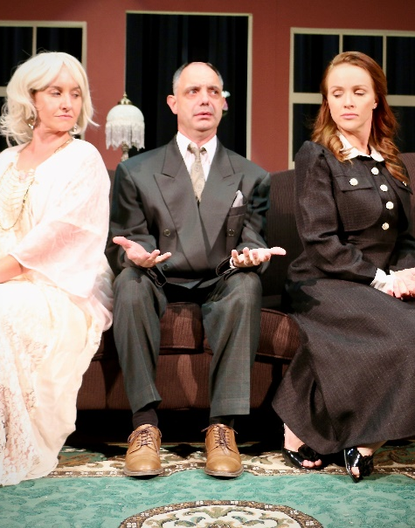

Pictured clockwise: Robin Hood cast members, Whispers in the Wind, Blithe Spirit, 6 Minute Warning, My Fair Lady, and Travis Dolter.

EPAC was pleased to feature numerous events in the 2025-26 season. Local productions were well attended and included River Valley Players’ “Blithe Spirit” and “One Act Plays” as well as Miss Joanne’s “Rise of Robin Hood” and “My Fair Lady”
Audiences were also delighted by Travis Dolter, Twilight Time, Buzz Brass, The Fugitives, Kinjo & Young, 6 Minute Warning and youth play “Whispers in the Air” by Quest Theatre.
2025-26 Performances


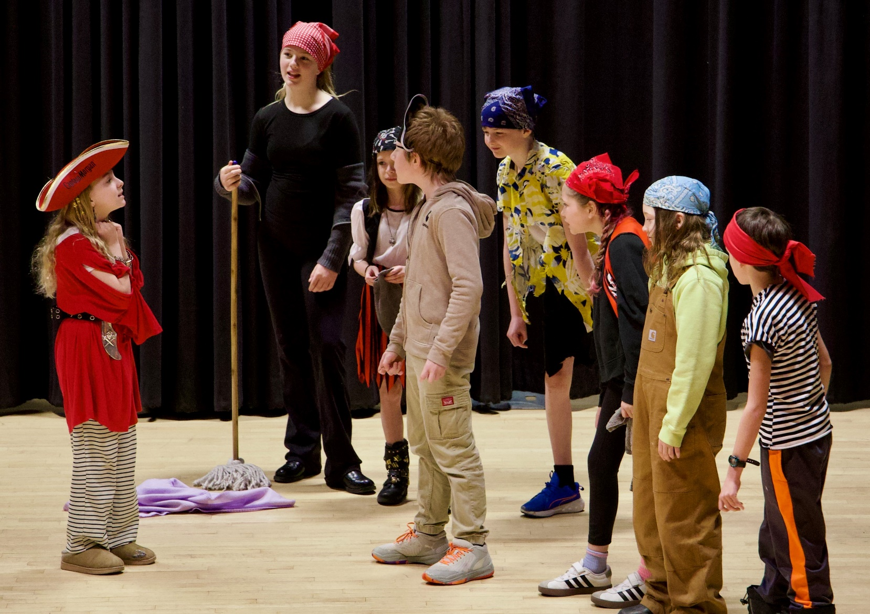
EPAC brings community together and is home to
- River Valley Players
- Valley Voices Community Choir
- Drayton Valley Performing Arts Festival
- Miss Joanne’s School of Dance Productions
Aside from concerts and theatre productions the Eleanor Pickup Arts Centre has facilitated church services, dance groups, school groups, business receptions, various meetings, weddings and parties.

Fiscal Year Rental Income Rentals Attendees
2026 $17,960 136 7,678
2025 $22,844 157 7,050
2024 $27,006 204 10,422
2023 $19,847 124 5,439

Festival Showcase 2026
Theatre Use

Capital Fundraising in 2025-26
$8,754
Rentals
136
Donations
$6,640
Phase II Expansion Fund
$358,571

Concession Revenue
$4,434
Volunteer Hours
1,845
Concert Sponsors
15
EPAC Info 2025-26
Financial Data

Eleanor Pickup Arts Centre
Statement of Revenues & Expenditures
Year Ended March 31, 2026
Total 2026 Total 2025
Revenues
Concerts $ 19,414 $ 45,225
Rental 17,715 22,844
Interest Income 9,120 13,137
Concession 7,549 11,001
Concert sponsorship 10,613 18,747
Grants 11,300 12,260
Fundraising 16,036 6,388
Non-capital donations 2,640 3,878
Gallery sales - -

$ 94,387 $ 133,480

Expenses
Concert expenses 30,757 40,075
Utilities 17,910 18,539 Janitorial 5,050 6,004
Repairs and maintenance 8,837 5,916
Advertising and promotion 8,549 6,809
Concession expenses 3,114 2,952
Insurance and licenses 3,644 3,442
Fundraising 240 5,135
Professional fees 2,600 2,600
Office 1,435 4,226
Memberships and conferences 2,444 2,443
Telephone 906 1,389
Interest and bank charges 179 178
Cost of sales-art - -
Travel - 577

$ 85,501 $ 100,487

EXCESS (DEFICIENCY) OF
REVENUES OVER EXPENDITURES
FROM OPERATIONS 8,886 32,993

OTHER INCOME
Amortization of deferred contribution 6,012 6,267
Amortization of equipment (6,033) (6,293)
___________________________________________
(21) (26)
___________________________________________
EXCESS (DEFICIENCY) OF REVENUES OVER EXPENDITURES $ 8,865 $ 32,967

Financial Data
Eleanor Pickup Arts Centre
Statement of Financial Position
Year Ended March 31, 2026
Total 2026 Total 2025

ASSETS
CURRENT
Cash $ 28,596 $ 19,194
Casino Funds 4,793 20,198
Short term investments 358,571 349,451
Accounts receivable 6,685 5,029
Goods and services tax recoverable - 1,470
Prepaid expenses 1,575 1,910
$400,220 $395,782
PROPERTY AND EQUIPMENT (Note 2) 65,875 61,923
___________________________________________
$466,095 457,705
LIABILITIES & NET ASSETS
CURRENT
Accounts payable $ 7,683 $ 1,090
Deposits held 950 800
Goods and services tax payable 154 210
Deferred casino revenue 4,793 20,198
Deferred donation revenue-capital 208,665 204,395
___________________________________________
222,245 226,693

DEFERRED CONTRIBUTIONS-EQUIPMENT 195,099 185,114
LESS: ACCUMULATED AMORTIZATION (129,307) (123,295)
___________________________________________
288,037 288,512

NET ASSETS
General fund 177,975 169,089
Capital fund 83 104
178,058 169,193
Total $ 466,095 $ 457,705
Financial compilation compiled by Palmer & Company
“All good things are wild and free.” Henry David Thoreau
For more information about the Eagle Point-Blue Rapids Parks Council events, recreational clubs, programs, and inquiries call 780-898-7275.
www.epbrparkscouncil.org

