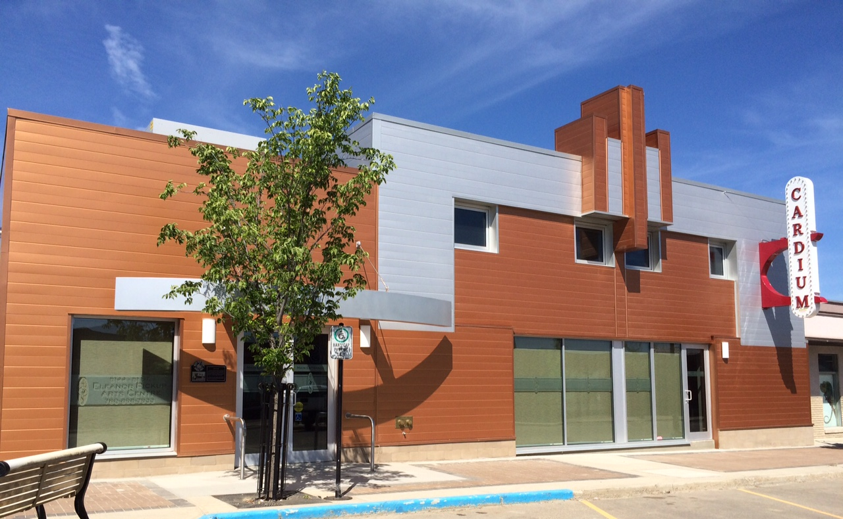
Moving Toward the Future

Eleanor Pickup Arts Centre
Annual Report 2024-25

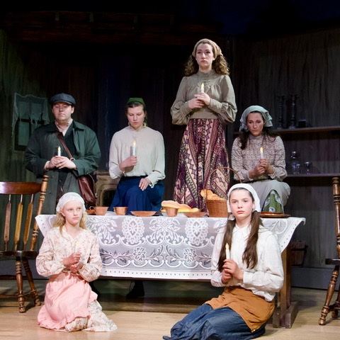
Moving Toward the Future
This year the Eleanor Pickup Art Centre board invested in a dream! A dream toward Phase II Expansion of the theatre! We are not breaking ground just yet, but we have invested in a design, and a plan to begin Phase II enhancement!
Pictured: Fiddler on the Roof, February 2025
Theatre expansion was always the goal, after the theatre changed from a movie house to becoming a live theatre venue. Phase II will include an expanded lobby, additional concession, green room, storage area, large rehearsal hall, two dressing rooms, corridor suitable for moving large props, and two income suites. The expansion will allow the venue to become a truly sustainable “arts centre” that can facilitate a wider array of performers and productions, all benefiting theatre goers. Through the support of the community, we hope this dream will be realized as we look to the future.

Who We Are…
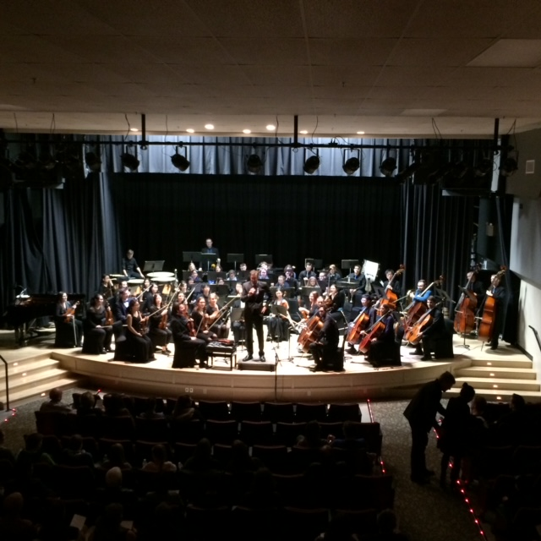
Located in the historic Cardium Theatre in Drayton Valley, Alberta, the Eleanor Pickup Arts Centre is a multipurpose performing arts venue for the greater Drayton Valley, Brazeau County & surrounding communities. Our aim is to encourage and foster participation in the performing arts while revitalizing the downtown area. Our non-profit organization strives to create a community where adults and youth alike, can perform and be entertained in this unique landmark venue.

2024-2025 Eleanor Pickup Art Centre Board of Directors
President-Sandra Bannard
Vice-President-Erin Hickman
Secretary-Mitzi Kobernik
Treasurer-Karstina Oscar
Theatre Manager-Onawa Hogan
Fundraising Coordinator-Erin Hickman
Volunteer Coordinator-Jessie Hendrigan
Marketing & Communications-Svetlana Kos
Construction Committee-Dave Davie
Art Gallery Curator-Aaron Laforest
Fundraising Committee-Karstina Oscar
Construction Committee-Joanne Nelson
Concession Coordinator-Tammy Pequin
Brazeau County Representative-Donna Wiltse
Town of Drayton Valley-Colin Clarke

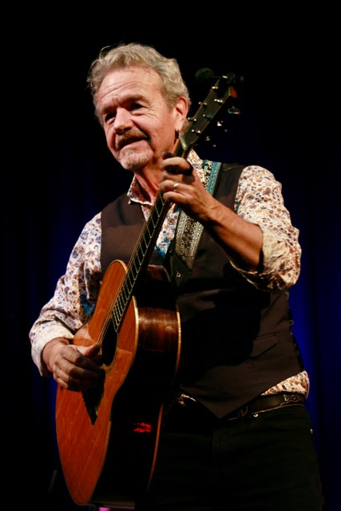
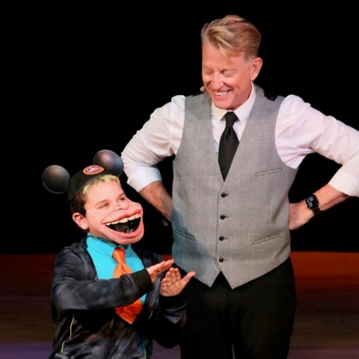
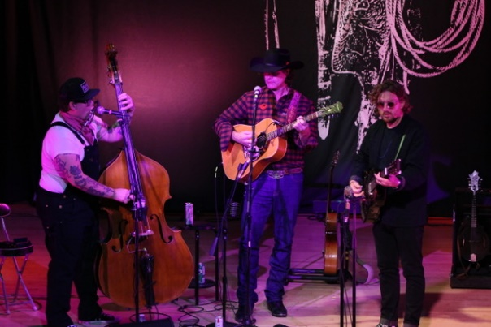
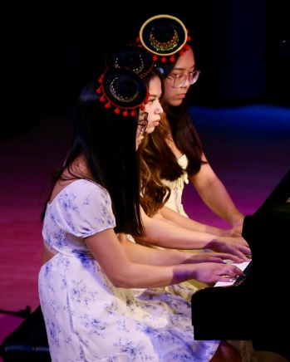
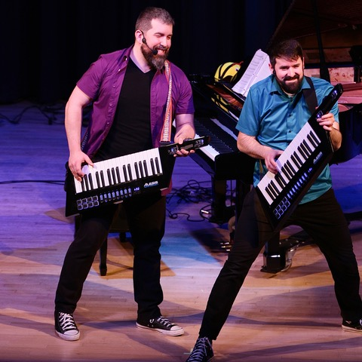
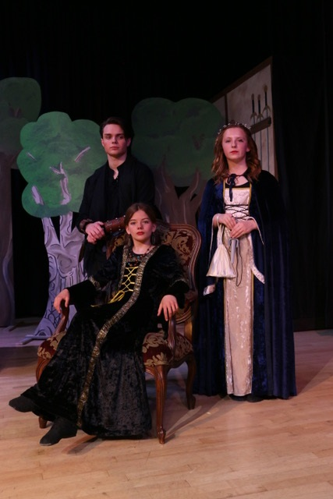
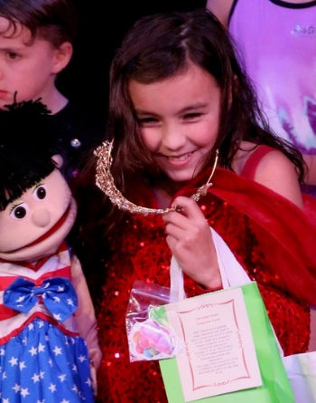
Pictured clockwise: Robin Hood cast members, Corb Lund, Jack Semple, Michael Harrison, DV Festival Performers Piano Trio, Taylor Holman, DV Has Talent, Piano Heist. Performances from 2023-24.

EPAC was pleased to feature numerous events in 2024-25. Local productions were incredibly well attended and included Fiddler on the Roof, Robin Hood, and Drayton Valley Has Talent.
Audiences were also delighted by George Canyon, Corb Lund, Jack Sample Plays Lightfoot, Molly’s Comedy Cabaret, Michael Harrison “Ventriloquist,” Axis Theatre, Nico Rhodes & Patrick Courtin in Piano Heist and Rum Ragged.
2024-25 Performances

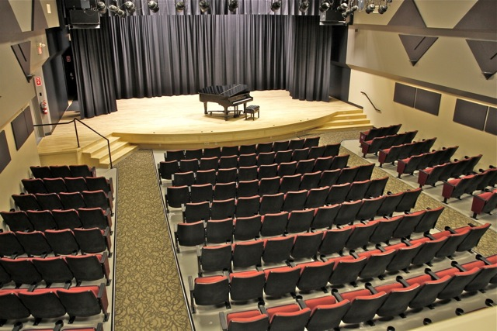

Aside from concerts and theatre productions the Eleanor Pickup Arts Centre facilitated church services, dance groups, school groups, business receptions, various meetings, and parties.

Fiscal Year Rental Income Rentals Attendees
2025 $22,844 157 7,050
2024 $27,006 204 10,422
2023 $19,847 124 5,439

Theatre Use

Committee Reports 2024-25
Treasurer's Report-Karstina Oscar
Our Financial Reports were completed by Verity LLP.
Thanks to our generous donors, we received $9,368 in donations and $18,500 from our concert sponsors.
Our fund for our future expansion continues to grow and is now just over $355,000.

Financial Data

Eleanor Pickup Arts Centre
Statement of Revenues & Expenditures
Year Ended March 31, 2025
Total 2025 Total 2024
Revenues
Concerts $ 45,225 $ 28,000
Rental 22,844 27,006
Interest Income 13,137 13,700
Concession 11,001 12,846
Concert sponsorship 18,747 9,021
Grants 12,260 6,060
Fundraising 6,388 5,390
Non-capital donations 3,878 2,791
Gallery sales - 279

$133,480 $ 105,093

Expenses
Concert expenses 40,075 61,906
Utilities 18,539 18,308 Janitorial 6,004 7,425
Repairs and maintenance 5,916 7,370
Advertising and promotion 6,809 5,070
Concession expenses 2,952 4,421
Insurance and licenses 3,644 3,442
Fundraising 5,135 2,760
Professional fees 2,600 2,516
Office 4,226 1,526
Memberships and conferences 2,443 1,155
Telephone 1,389 971
Interest and bank charges 178 254
Cost of sales-art - 187
Travel 577 151

$100,487 $ 117,462

EXCESS (DEFICIENCY) OF
REVENUES OVER EXPENDITURES
FROM OPERATIONS 32,993 (12,369)

OTHER INCOME
Amortization of deferred contribution 6,267 7,834
Amortization of equipment (6,293) (7,866))
___________________________________________
(26) (32)
___________________________________________
EXCESS (DEFICIENCY) OF REVENUES OVER EXPENDITURES $ 32,967 $ (12,401)

Financial Data
Eleanor Pickup Arts Centre
Statement of Financial Position
Year Ended March 31, 2025
Total 2025 Total 2024

ASSETS
CURRENT
Cash $ 19,194 $ 3,867
Casino Funds 20,198 1,789
Short term investments 349,451 349,121
Accounts receivable 5,029 2,632
Goods and services tax recoverable - 1,470
Prepaid expenses 1,910 11,102
$395,782 $369,981
PROPERTY AND EQUIPMENT (Note 2) 61,923 53,216
___________________________________________
$457,705 423,197
LIABILITIES & NET ASSETS
CURRENT
Accounts payable $ 1,090 $ 18,351
Deposits held 800 800
Goods and services tax payable 210 -
Deferred casino revenue 20,198 1,789
Deferred donation revenue-capital 204,395 212,945
___________________________________________
226,693 233,885

DEFERRED CONTRIBUTIONS-EQUIPMENT 185,144 170,114
LESS: ACCUMULATED AMORTIZATION (123,295) (117,028)
___________________________________________
288,512 286,971

NET ASSETS
Unrestricted net assets 169,089 136,096
Capital fund 104 130
169,193 136,226
Total $ 457,705 $ 423,197
Financial compilation compiled by VERITY LLP
“All good things are wild and free.” Henry David Thoreau
For more information about the Eagle Point-Blue Rapids Parks Council events, recreational clubs, programs, and inquiries call 780-898-7275.
www.epbrparkscouncil.org

